TASK | General cleaning of brake components on fork lift truck
LOCATION OF USE | Workshop and field engineers |  | Assessment  No |  | 004
PRODUCT NAME | Brake Cleaner |  |  |  | 004
DESCRIPTION OF SUBSTANCE | Odourless clear liquid in an aerosol can |  |  |  | 004
MANUFACTURER | SEH Logistics |  |  |  | 004
MANUFACTURERS CONTACT | Unit FFB 9  Bonehill Farm  Tamworth  Staffordshire. B78 3HP  Tel: 07725 041331 |  |  |  | 004
ASSESSOR | Martin Monaghan CMIOSH |  | Date |  | 23 07 24
TITLE | Health and Safety Consultant |  | Review by |  | 23 07 26
Personnel Performing Task  (Please list below)  Technicians/ Fitters/ Workshop Operatives |  | Time Spent  (Minutes/day)  As and when required, amounting to a few minutes per day | Training Given 
 |  |  | Yes

MSDS Revision Date | Hazard Statement
4th August 2014 | H225 Highly flammable liquid and vapour.  H304 May be fatal if swallowed and enters airways.  H315 Causes skin irritation.  H336 May cause drowsiness or dizziness.  H411 Toxic to aquatic life with long lasting effects.

Assessment to be conducted in Association with Hazard Data Sheets, a full current copy of which must be attached to this assessment.

Please denote the hazardous properties of the substances used in the task with a

NEW INTERNATIONAL GLOBALLY HARMONISED HAZARD SYMBOLS
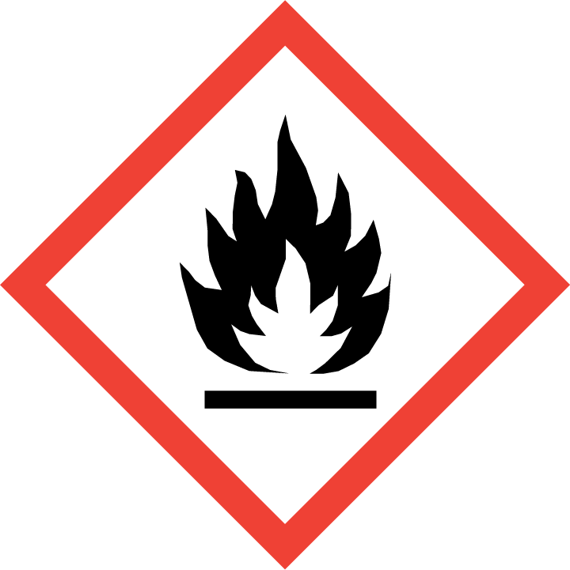 | 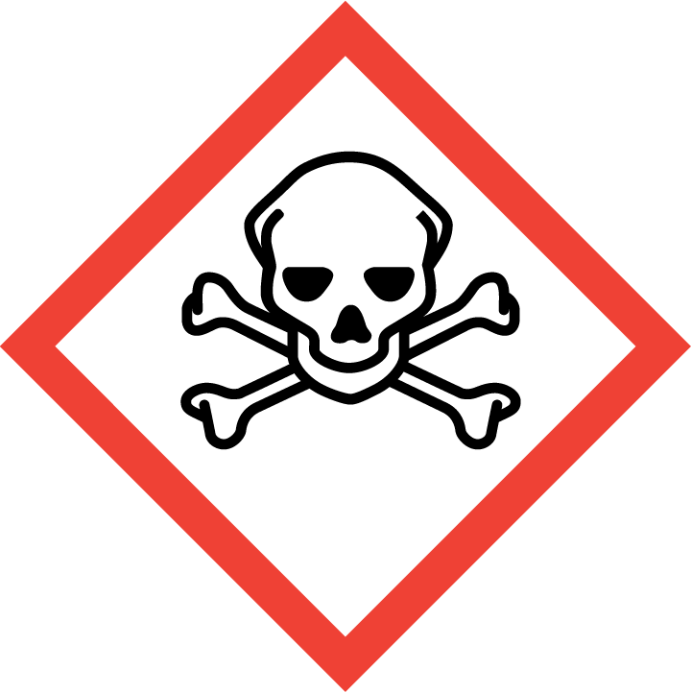 | 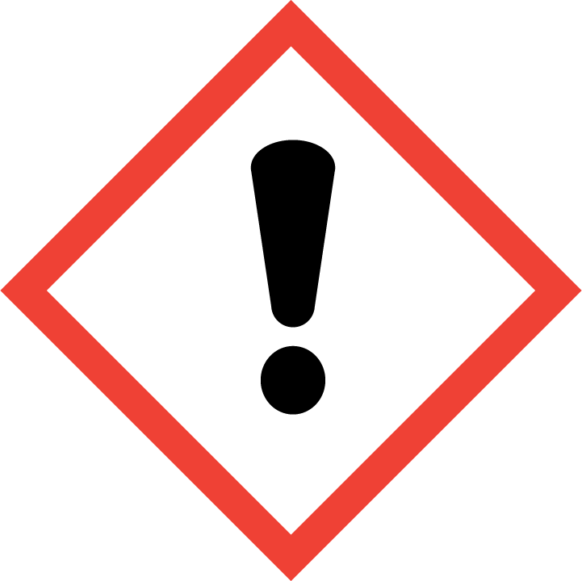 | 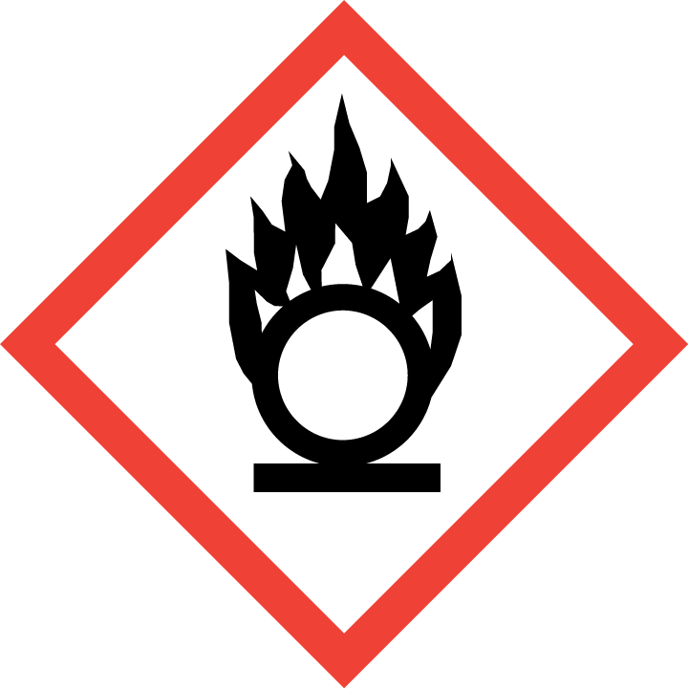 | 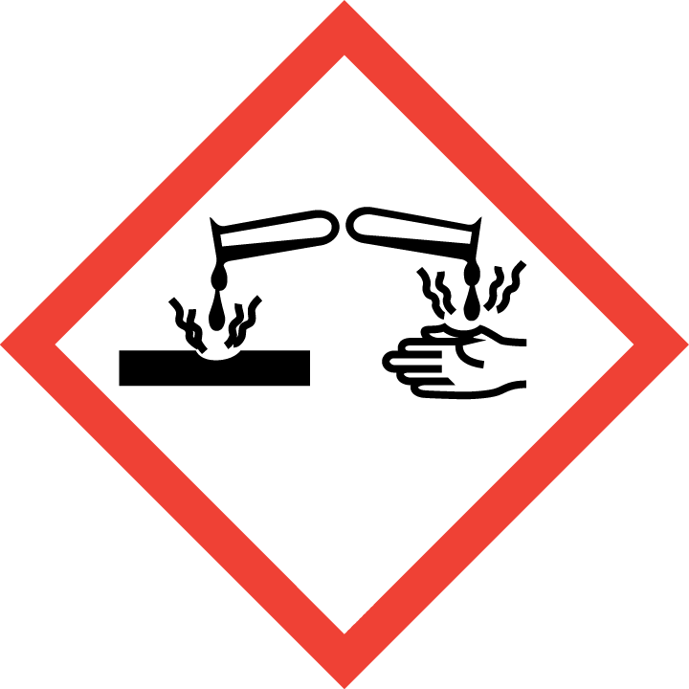 | 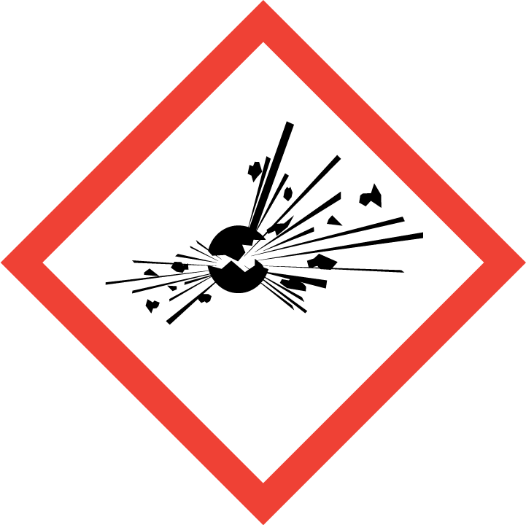 | 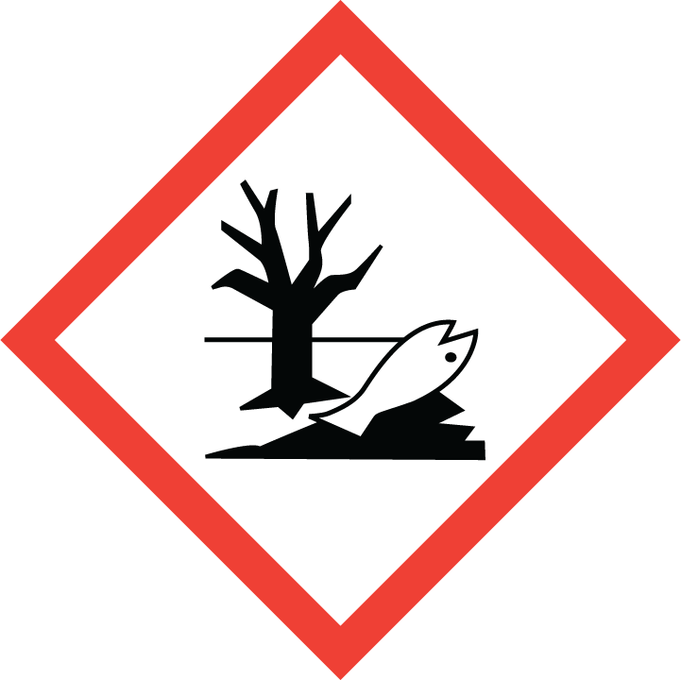 | 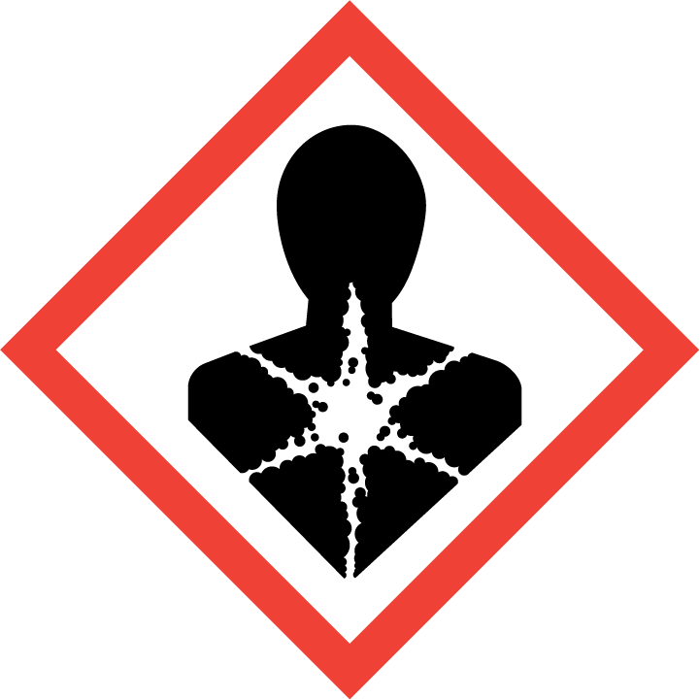
Flammable | Toxic | Harmful | Oxidising | Corrosive | Explosive | Harmful to the environment | Health Hazards i.e. respiratory sensitisation or carcinogenicity

SMOKING, EATING AND DRINKING ARE PROHIBITED IN THE WORK AREAS.
Information, Instruction and Training must be provided to all users. Young Persons, New or Expectant Mothers and other vulnerable groups must not use or be exposed to this product.

WORKPLACE EXPOSURE LIMITS (WEL’s)
IMPORTANT!
Refer to Workplace Exposure Levels information provided in the Manufacturers Safety Data and revise control measures if exposure levels likely to be reached.

ROUTE OF EXPOSURE
Skin |  | Eyes |  | Inhalation
Ingestion |  | Cuts/abrasions |  | Systemic

PERSONS AT RISK
User of product |  | Co workers |  | Members of the public

ROUTE OF EXPOSURE |   FIRST AID MEASURES
Eyes | Important! Immediately rinse with water for at least 15 minutes. Remove contact lenses, if present and easy to do. Continue rinsing. Continue to rinse for at least 15 minutes and get medical attention.
Skin | Wash skin thoroughly with soap and water. Remove contaminated clothing immediately and wash skin with soap and water.
Inhalation | In case of inhalation of spray mist: Move person into fresh air and keep at rest. Remove affected person from source of contamination. If breathing stops, provide artificial respiration. Keep affected person warm and at rest. If in doubt, get medical attention promptly.
Ingestion | Immediately rinse mouth and provide fresh air. Do not induce vomiting. Get medical attention if any discomfort continues.
In all cases of doubt, or if symptoms persist seek medical attention. Never give anything by mouth to an unconscious person. If unconscious, place in recovery position and seek medical advice.

PERSONAL PROTECTIVE EQUIPMENT
 |  |  |  | 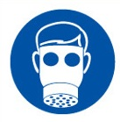 |  | 
YES | YES | YES/NO |  | YES/NO | YES | YES/NO
 |  |  |  |  | Chemical Resistant
Wear splash-proof eye goggles to prevent any possibility of eye contact. | Wear appropriate clothing to prevent repeated or prolonged skin contact. |  | LEV or facemask to be worn with filter for organic substances if air contamination exceeds acceptable level |  | Protective gloves must be used if there is a risk of direct contact or splash. Use protective gloves made of: Nitrile.

HANDLING | STORAGE | TRANSPORT | DISPOSAL
Keep away from heat, sparks and open flame. Read and follow manufacturer's recommendations. | Store in a cool location in rear of vehicle away from heat sources and direct sunlight. Ensure cans are stowed securely with the lids firmly on. Store in flammable store when at factory. | Only carry minimum required amounts (1 can). Carry secured upright within the vehicle away from direct sunlight. | Must not be disposed off with household waste. Used, degraded or contaminated product may be classified as hazardous waste. Return empty aerosols to the factory for disposal.

REQUIRED CONTROL MEASURES
- Ensure only minimum amounts are transported and used (1 can).
- Ensure approved impermeable gloves are used at all times.
- Ensure overalls are worn and these are suitably laundered.
- Ensure suitable chemical resistant goggles are worn when spraying lubricant.
- Ensure that work is undertaken in well ventilated areas, where significant spray is required ensure a suitable vapour/particle respirator is used.
- Do not apply near walkways and clear any areas of overspray.
- Ensure that Engineers are equipped with antibacterial hand washes and wipes and that good hygiene practices are enforced
- Provide engineers with suitable barrier creams.
- Ensure that the aerosol is always used with the straw attachment to reduce the risk of overspray.
- Do not apply near heat sources or sources of ignition.

FIRE PRECAUTIONS
Foam. Dry chemicals. Water spray. Carbon dioxide (CO2).

ACCIDENTAL RELEASE/SPILLAGE PROCEDURES
In case of inadequate ventilation, use respiratory protection. Use protective gloves, goggles and suitable protective clothing. Avoid inhalation of vapours and contact with skin and eyes. Provide adequate ventilation.

Environmental precautions : Prevent entry into drains.

Methods and material for containment and cleaning up Absorb with sand or other inert absorbent. Containers with collected spillage must be properly labelled with correct contents and hazard symbol.

MONITORING REQUIREMENTS AND HEALTH SURVEILLANCE
Health surveillance is not in place for workers exposed to this product.

